- UK GDP growth beat expectations again in May, meaning output remains on track for another quarter of solid growth in Q2. This adds to the evidence that the economy has now firmly turned a corner and supports our above-consensus forecast for GDP growth in 2024.
- New Chancellor Rachel Reeves used her maiden speech to emphasise that reforms to the planning system will play a major role in the government's mission to boost economic growth. While we view this as a laudable aim, we will need to see more detail on the plans and evidence of delivery before we would feel confident enough to raise our forecast for potential output growth.
We've been arguing for some time that 2024 would see UK GDP growth turn a corner and outperform the consensus forecast. GDP data for the first four months of the year had represented an encouraging start, and this week's release for May bolstered our conviction that the recovery has built some strong momentum.
The Office for National Statistics reported that GDP rose 0.4% m/m in May. Stronger activity in May partly reflected some payback as temporary factors which dragged on output in the distribution and construction sectors in April, namely the earlier-than-usual Easter and a period of poor weather, unwound. But elsewhere it was a story of broad-based strength, with activity in the business services sector remaining robust, while manufacturing output also rose (Chart 1).
We expect output to dip in June given four days of strikes by junior doctors will have weighed on activity in the health sector. Meanwhile, it's unlikely that May's strength in retail sales will be sustained into the following month and business survey data suggests output in the private sector grew at a slower pace in June. But even after accounting for a softer end to the quarter, we estimate that GDP grew by 0.6% in Q2. Given the drags from the early Easter and strikes, this would be an impressive achievement.
Chart 1: May saw a broad-based expansion in GDP
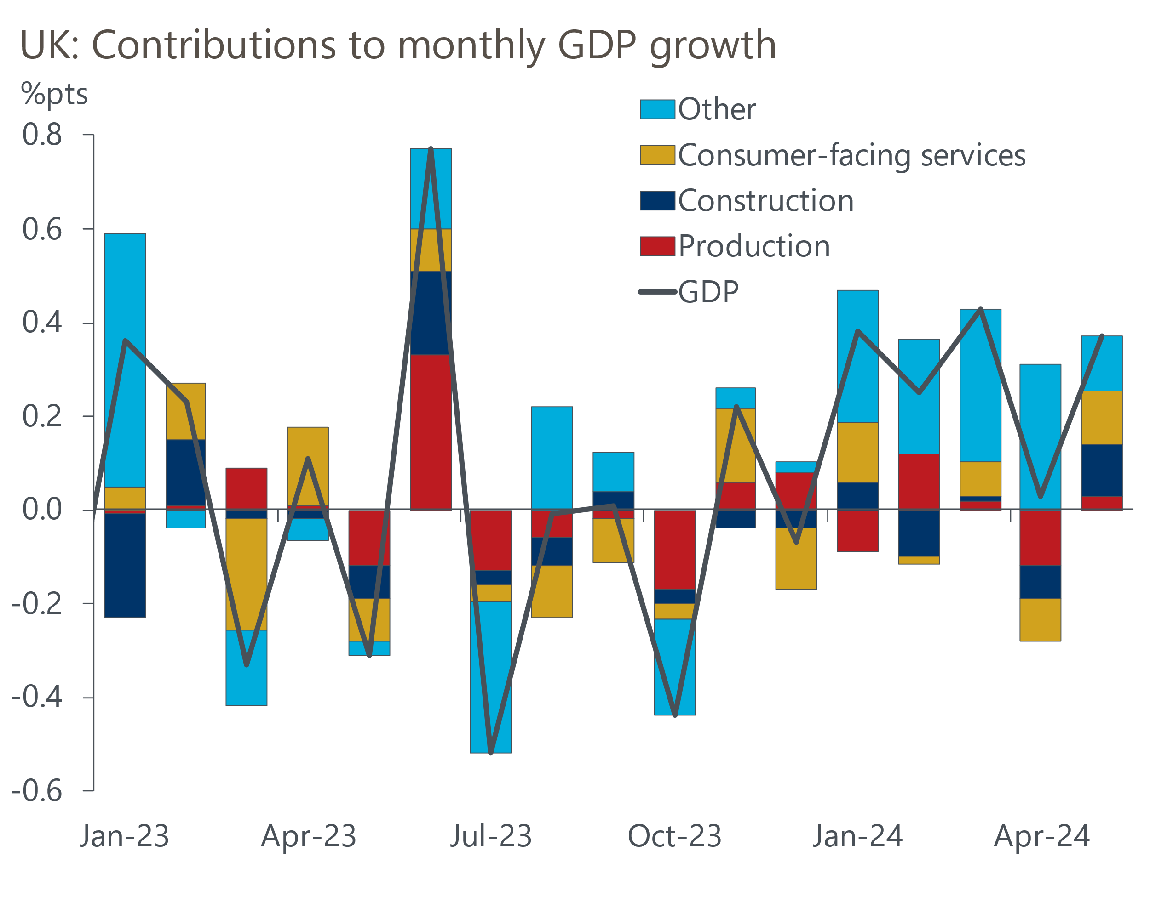
Source: Haver Analytics

Therefore, after five months' worth of data, it's difficult to escape the conclusion that the economic recovery is carrying decent momentum. We think the boost to real household incomes from a sharp fall in inflation, and rising consumer confidence, means GDP will continue to grow at a decent pace in H2 2024. Unless there are large historical data revisions. the consensus forecast of 0.6% for 2024 in July's Focus Economics survey appears far too low, and our forecast that GDP will grow by 1.1% looks well placed.
Though we expect stronger consumer spending to be the primary driver of growth over the next couple of years, the economy's prospects in the longer-term will depend on improvements to its supply-side. This week, new Chancellor Rachel Reeves used her maiden speech to highlight that reforms to the planning system would be a key tenet of the government's mission to boost economic growth.
This is a very sensible aim for a cash-strapped government – reform of the planning system was one of the seven recommendations we made in our proposals for boosting potential output, published before the March 2023 Budget. But we need to see more detail on the plans and evidence that the reforms are delivering tangible benefits to the economy before we will feel confident enough to raise our forecast.
The Office for Budget Responsibility is likely to adopt a similar stance, particularly given that its potential output forecasts are already higher than those of most other forecasters. So if the government hopes that stronger growth will enable it to reduce the scale of fiscal consolidation required to comply with its fiscal rules, it is likely to have to wait a few years for that to become a reality.
With the general election now in the rear-view mirror, the Bank of England's Monetary Policy Committee ended its period of silence with a flurry of speeches from MPC members this week. Jonathan Haskel and Catherine Mann both signalled that they were unlikely to vote for looser policy in the near-term given underlying inflationary pressures were still inconsistent with the BoE's 2% inflation target. Meanwhile, comments by BoE Chief Economist Huw Pill provided little steer on the prospect of an August rate cut. Pill remarked that on one hand, the latest data remained consistent with the view that inflationary pressures "have now been contained and may be starting to revert towards levels that are more consistent with the inflation target". But on the other hand, he also noted that the key drivers of UK inflation were still showing "uncomfortable strength".
On balance, the prospects of an August rate cut haven't changed much this week. In common with other central banks, the MPC's focus has been almost exclusively on inflation in recent years, with growth playing barely any role in their thinking. So we doubt that May's stronger output data would derail a potential rate cut.
Both Haskel and Mann have long been in the MPC's hawkish camp, therefore we had already written off the chances of either member voting for a rate cut in August. Though Pill is an internal MPC member, a group that generally votes as a pack, we've long identified him as the most hawkish of the four internal members that are yet to vote for a rate cut. With an August rate cut requiring just three additional committee members to vote for looser policy, we don’t see Pill as the swing voter.
So we maintain our forecast that the MPC will cut Bank Rate by 25bps in August. Market pricing suggests an August cut is close to being a 50/50 call. Though the doves have signalled that backward-looking measures of inflation persistence are becoming less important to their decision-making, next week's inflation and labour market releases still have the potential to tip the balance, not least because of how they impact on market pricing.

The week ahead
A flurry of economic releases next week begins with inflation data for June. CPI inflation fell back to the BoE's 2% target in May as base effects and firms passing on their lower energy costs to consumers continued to weigh on prices in the food and services sectors. We think there's a good chance the same drivers weakened price pressures in these categories further in June. Therefore, we expect headline CPI inflation to have slowed to 1.8% in June.
We see little reason to think May's labour market release will provide any major surprises on pay. Strong base effects will weigh on pay growth, while timelier indicators from HMRC and the BoE's Decision Maker Panel have pointed to a cooling in pay pressures. As a result, we forecast that headline total pay growth fell to 5.6% in the three months to May.
Labour Force Survey data remains very volatile, with the ONS yet to fully implement changes that it hopes will improve sample sizes. May's declines in vacancies and HMRC's measure of employees were smaller than in preceding months, suggesting the pace at which labour demand is cooling may be starting to moderate. This, in combination with February's elevated unemployment outturn falling out of the three-month average, means we think the ONS will report that the unemployment rate edged down to 4.3% in the three months to May.
Retail sales have been incredibly noisy in recent months, with the ONS claiming that the earlier-than-usual Easter and poor weather played roles in the volatility. May's rebound in sales volumes more than made up for April's collapse. But May's strength was partly due to a very large increase in non-store sales that is unlikely to be sustained. Therefore, we expect a drop in non-store sales to have driven a 0.3% m/m fall in retail sales in June. This is consistent with the CBI and BRC surveys, which also pointed to weakness in online sales and a decline in overall retailing performance in June.
Table 1: Week ahead calendar
Date | Events | Period | Measure | Unit | Previous | Forecast
Jul 17 | CPI inflation | Jun | m/m | % | 0.3 | -0.0
Jul 17 | CPI inflation | Jun | y/y | % | 2.0 | 1.8
Jul 17 | RPI inflation | Jun | m/m | % | 0.4 | 0.3
Jul 17 | RPI inflation | Jun | y/y | % | 3.0 | 2.9
Jul 17 | Producer input prices | Jun | m/m | % | 0.0 | 0.0
Jul 17 | Producer input prices | Jun | y/y | % | -0.1 | 1.1
Jul 17 | Producer output prices | Jun | m/m | % | -0.1 | 0.1
Jul 17 | Producer output prices | Jun | y/y | % | 1.6 | 1.7
Jul 18 | LFS unemployment | Mar-May | Rate | % | 4.4 | 4.3
Jul 18 | Average earnings (total pay) | May | 3m, y/y | % | 5.9 | 5.6
Jul 18 | Average earnings (regular pay) | May | 3m, y/y | % | 6.0 | 5.7
Jul 19 | Public finances | Jun | PSNB ex | £bn | 15.0 | 14.7
Jul 19 | Retail sales inc fuel | Jun | m/m | % | 2.9 | -0.3
Jul 19 | Retail sales inc fuel | Jun | y/y | % | 1.3 | 0.4
Source: Oxford Economics

Key forecasts
Table 2: UK forecast overview
(Annual percentage changes unless specified)
 | 2022 | 2023 | 2024 | 2025 | 2026 | 2027
GDP | 4.3 | 0.1 | 1.1 | 2.0 | 1.9 | 1.7
Private consumption | 4.8 | 0.2 | 0.8 | 2.4 | 2.2 | 1.6
Fixed investment | 8.0 | 2.2 | -0.1 | 1.3 | 2.7 | 2.1
Government consumption | 2.3 | 0.5 | 2.9 | 3.2 | 1.6 | 1.5
Exports of goods and services | 9.0 | -0.5 | -1.2 | 2.5 | 2.4 | 1.7
Imports of goods and services | 14.6 | -1.5 | -0.3 | 4.7 | 2.9 | 1.9
Industrial Production | -3.5 | -0.4 | 0.0 | 0.9 | 1.5 | 1.2
Consumer prices | 9.1 | 7.3 | 2.5 | 2.5 | 2.3 | 2.2
Unemployment rate (%) | 3.9 | 4.0 | 4.3 | 4.1 | 3.8 | 3.8
Current a/c balance (% of GDP) | -3.1 | -3.3 | -3.3 | -3.4 | -3.4 | -3.4
Government balance (% of GDP) | 4.4 | 5.0 | 3.7 | 3.2 | 2.3 | 1.5
Cen. bank policy rate (%, EOP) | 3.50 | 5.25 | 4.75 | 3.75 | 2.75 | 2.00
10yr govt. bond yield (%, EOP) | 3.67 | 3.54 | 4.00 | 3.67 | 3.19 | 2.85
Exchange rate (US$ per £, EOP) | 1.20 | 1.27 | 1.26 | 1.28 | 1.30 | 1.32
Exchange rate (euro per £, EOP) | 1.13 | 1.15 | 1.18 | 1.18 | 1.17 | 1.16
Source: Oxford Economics
Table 3: Quarterly forecasts for the UK
 | 2024 |  |  |  | 2025
 | Q1 | Q2 | Q3 | Q4 | Q1 | Q2 | Q3 | Q4
GDP (% year) | 0.3 | 0.7 | 1.2 | 2.0 | 1.8 | 2.0 | 2.1 | 2.2
CPI inflation (% year) | 3.5 | 2.1 | 2.0 | 2.5 | 2.5 | 2.4 | 2.7 | 2.5
Bank Rate (%, EOP) | 5.25 | 5.25 | 5.00 | 4.75 | 4.50 | 4.25 | 4.00 | 3.75
10yr gilt yield (%, EOP) | 3.95 | 4.17 | 4.05 | 4.00 | 3.92 | 3.85 | 3.76 | 3.67
US$ per £ (EOP) | 1.26 | 1.26 | 1.26 | 1.26 | 1.26 | 1.27 | 1.27 | 1.28
Euro per £ (EOP) | 1.17 | 1.18 | 1.18 | 1.18 | 1.18 | 1.18 | 1.18 | 1.18
Source: Oxford Economics

Latest Country Economic Forecast:
June 18, 2024

Recent publications

Data Insights
Upside surprise for GDP suggests recovery has momentum
June's lower composite PMI isn't cause for concern
Manufacturing PMI reports a gradual recovery in activity
Mortgage demand remains very sensitive to interest rates
National accounts point to a slightly stronger start to 2024

Research Briefings
MPC prepares the ground for an August rate cut
Why Labour and Tory manifestos are a missed opportunity
MPC preview – The clues will be in the language
Will the BoE slow QT?
Why the neutral interest rate will stay structurally low

Contacts

Oxford Economics' UK team
- Andrew Goodwin - Chief UK Economist - agoodwin@oxfordeconomics.com
- Edward Allenby - UK Economist - eallenby@oxfordeconomics.com

